* Spring Boot provide all the configurations, we don’t have to do it manually anymore (for example dispatcherservlet and so on).
* It has a embedded http server as well, so we can just run it normally as a jar package instead of war if we wanted.

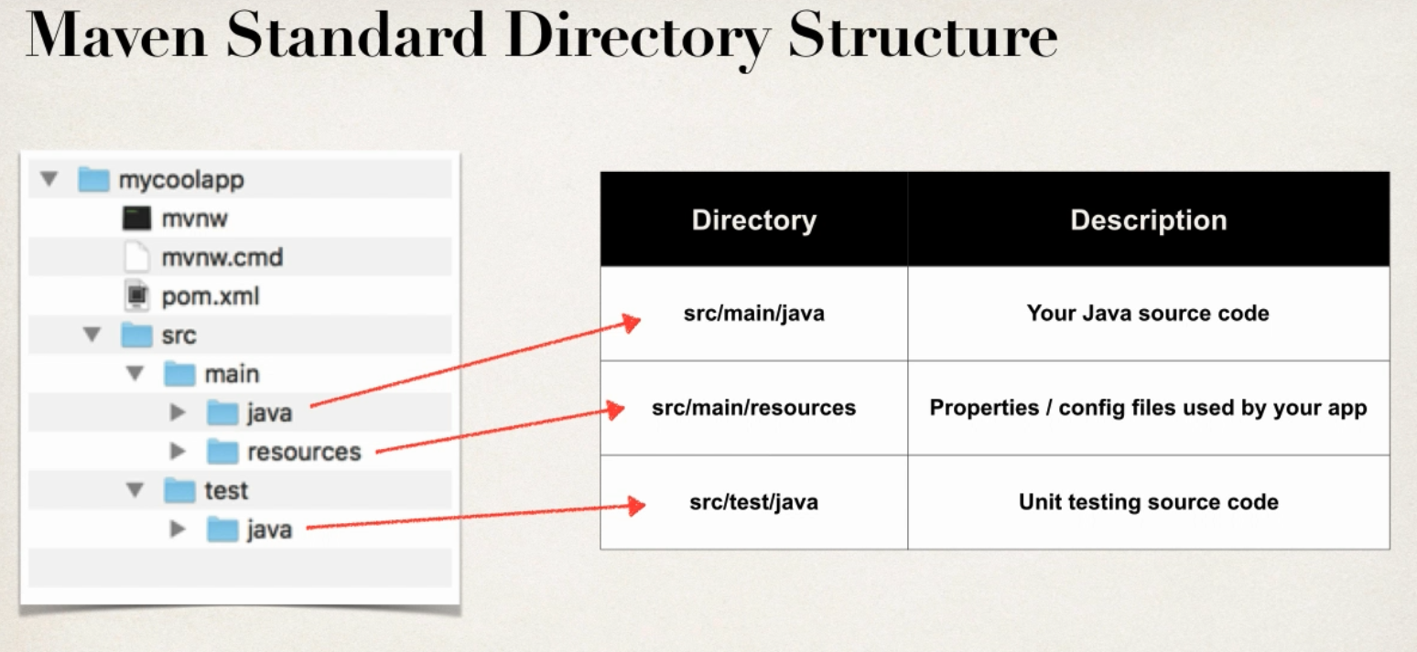

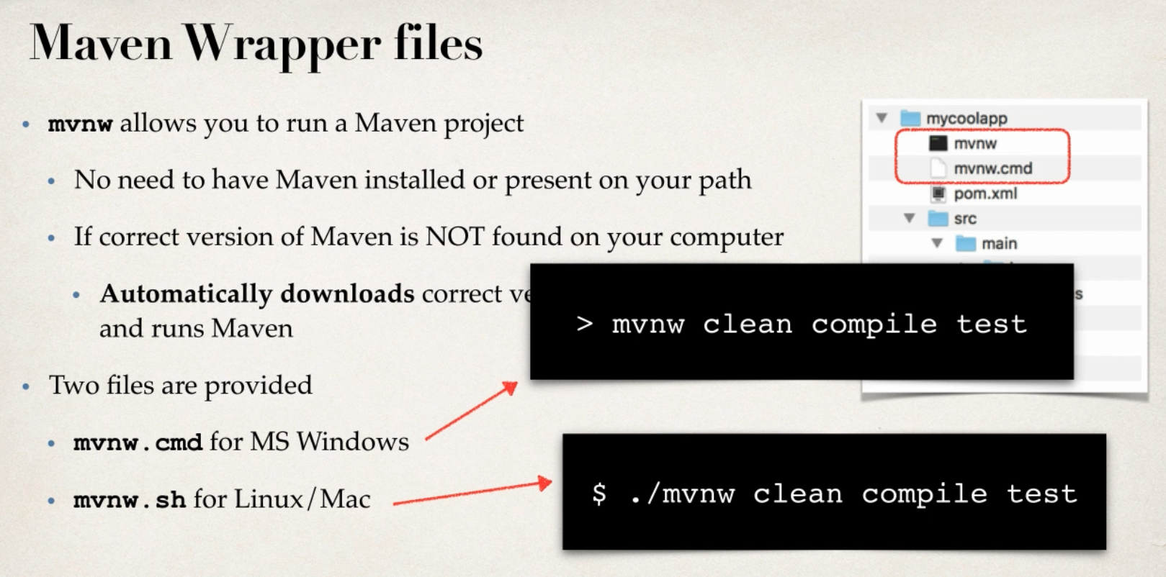

* In case we have maven installed, we can delete those to mvnw files.

By default, spring gives us a main spring boot application class.

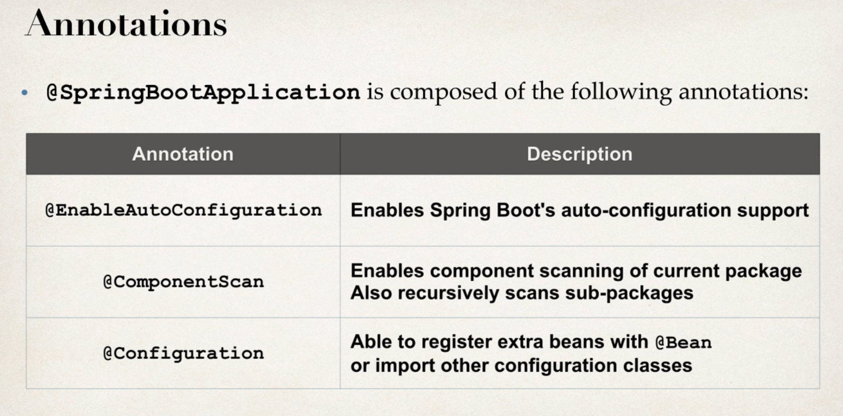

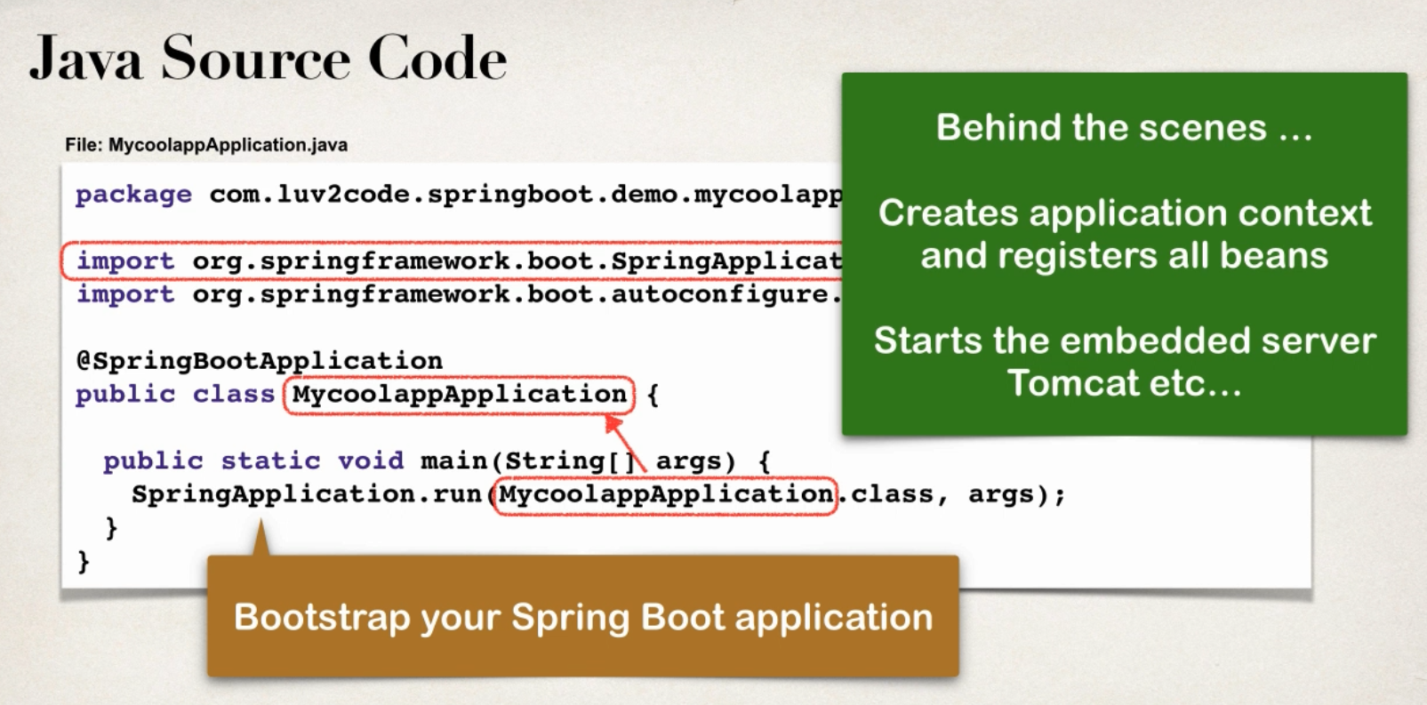

* **Bootstrap** means the application will start the process of starting itself. Examples of bootstrapping – Code that starts when pc start, which loads everything else including OS.
* @SpringBootApplication annotation make sure that the component scan will work on any sub-packages.

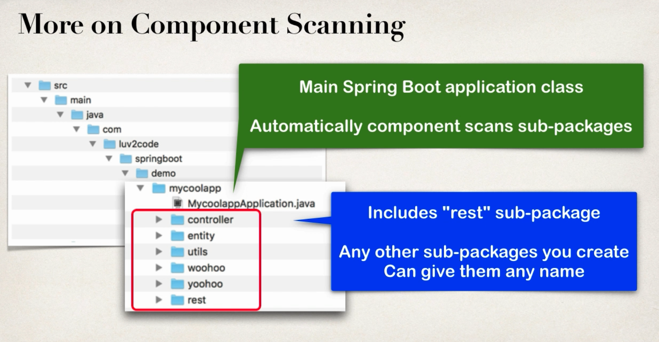

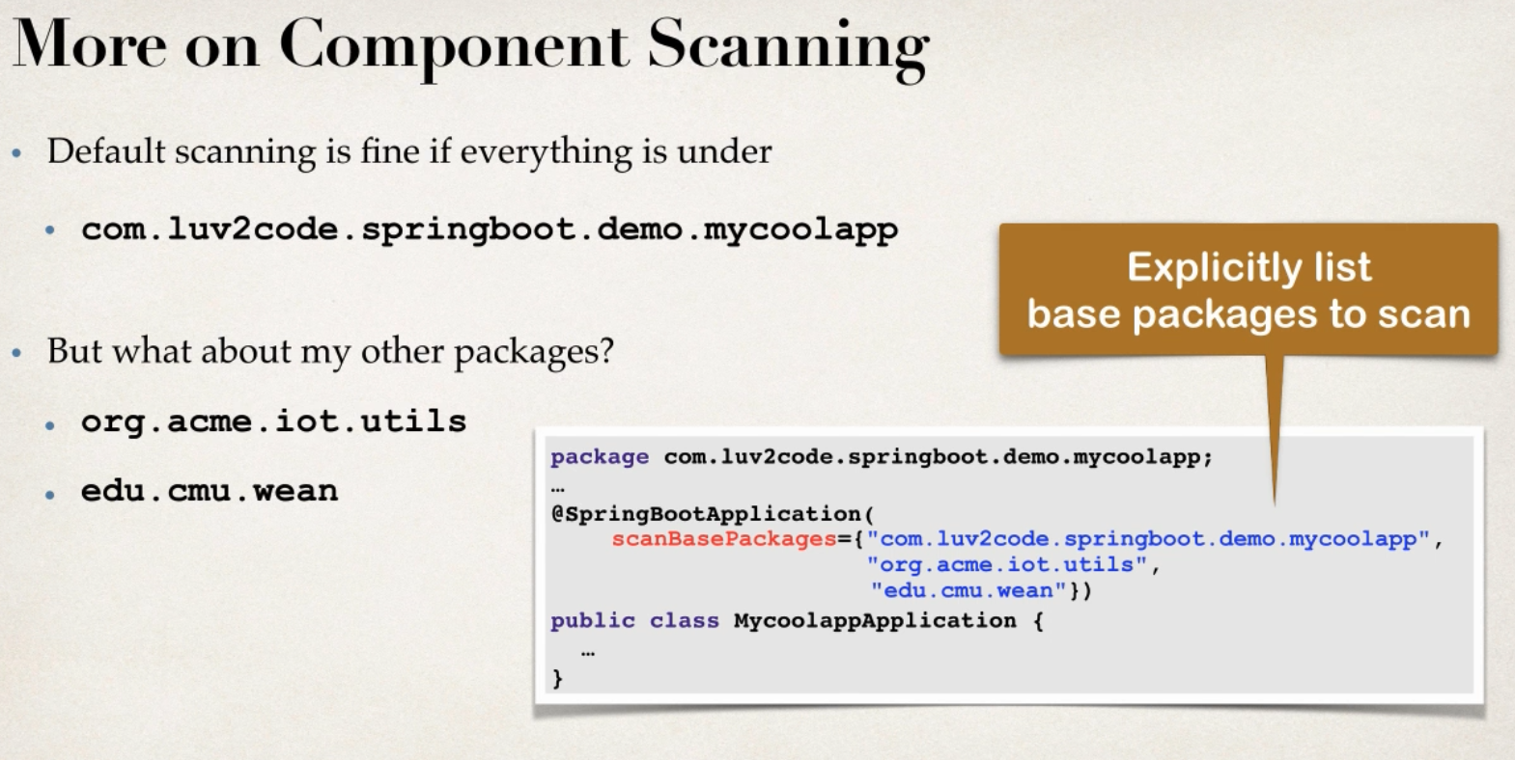

**Application properties:** Similar to .env files in express framework (can’t remember the asp.net version).

* We can define any custom properties here.
* Spring boot application can access properties using @Value annotations

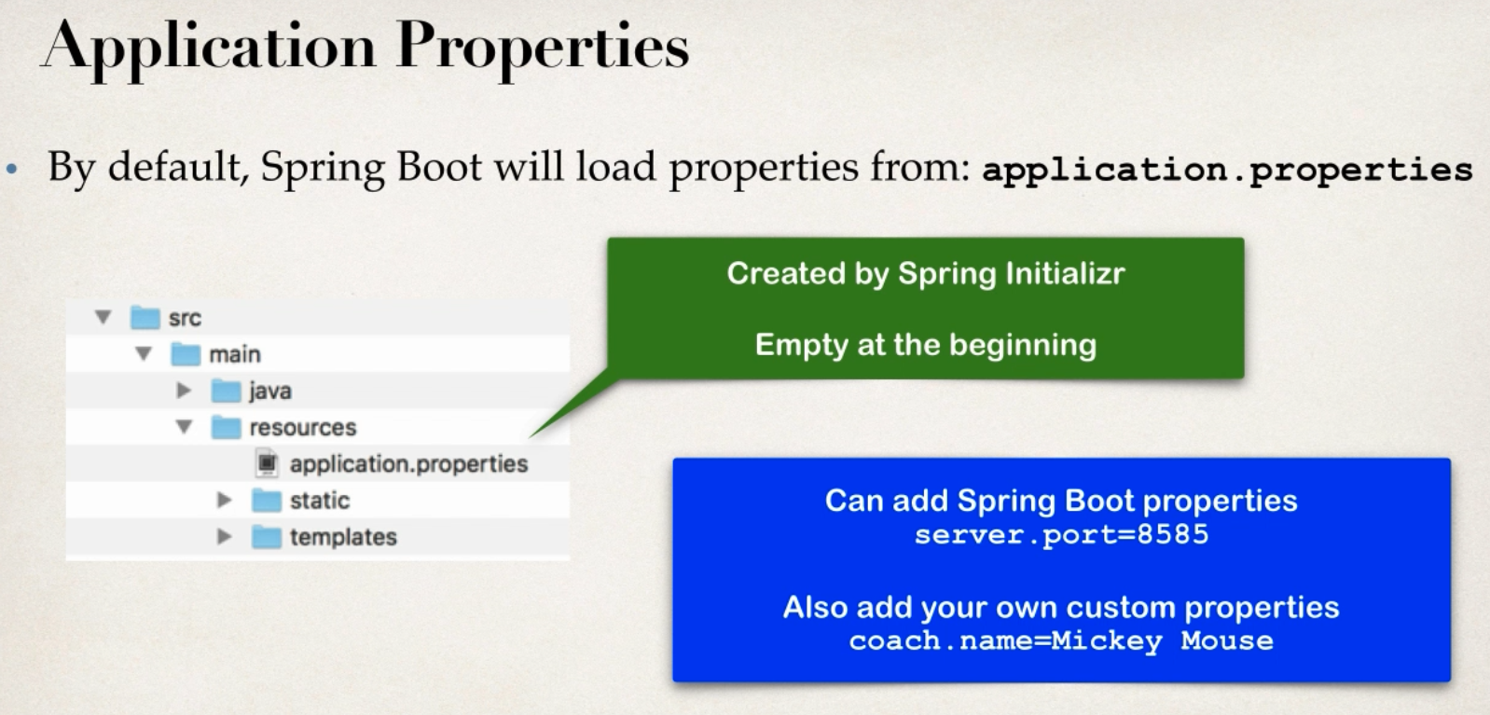

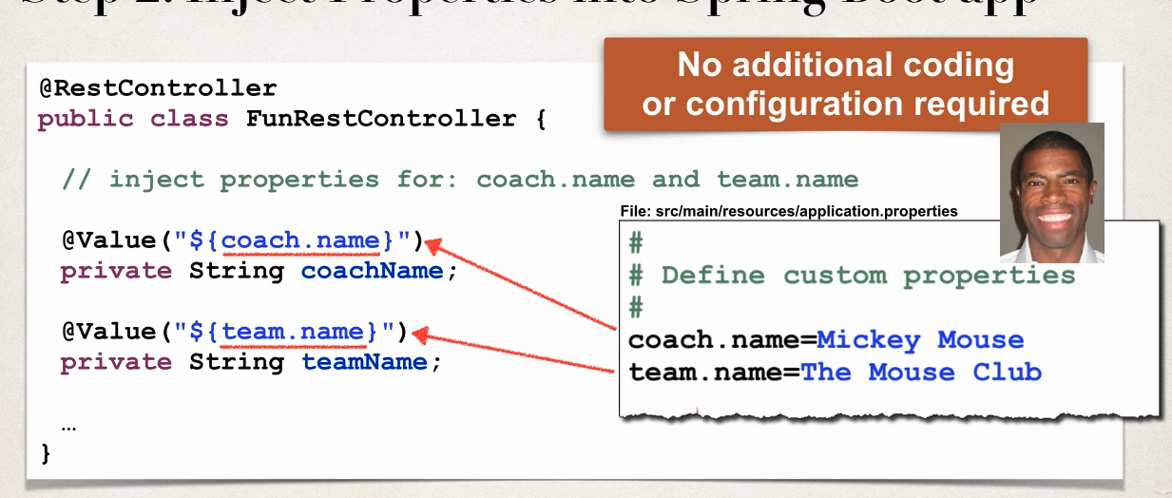

**Static files:** Similar to static files in express.

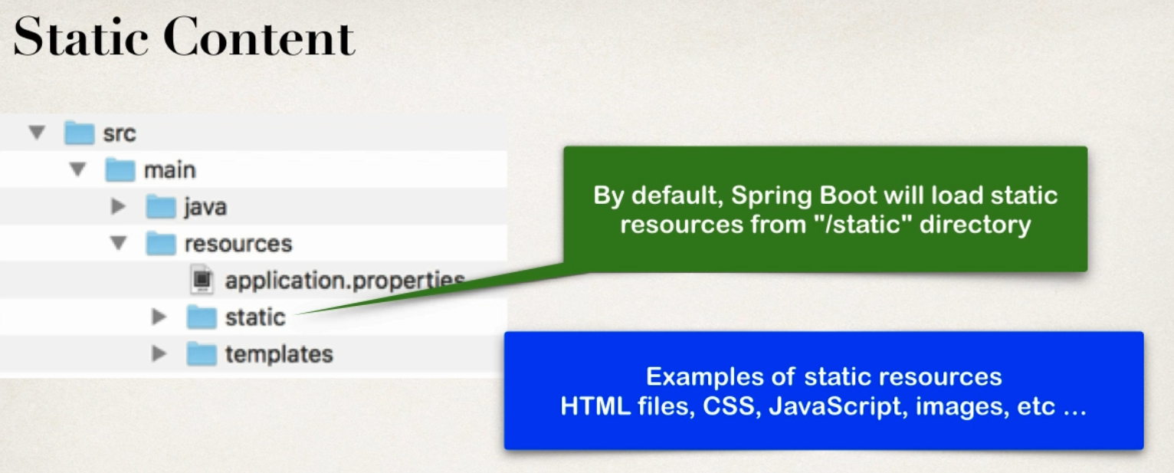

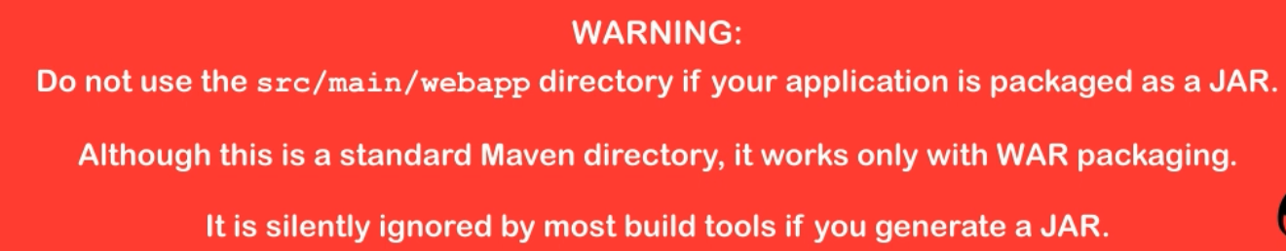

**Templates:** Template files here for dynamic content.

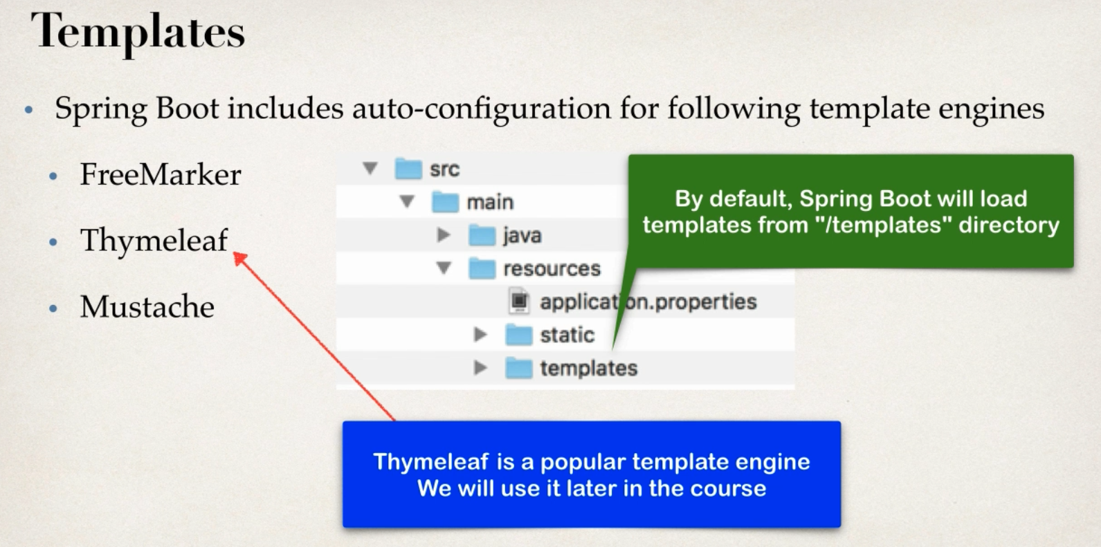

We can actually check which dependency spring boot gives us by default from the maven dependency options in IntelliJ

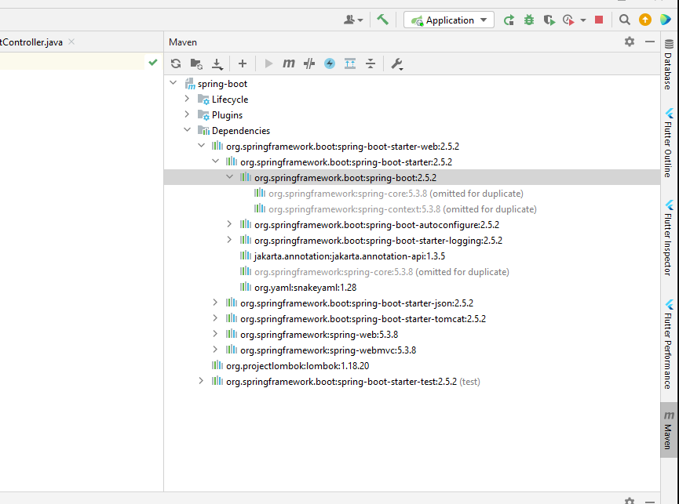

* We can run the java application from command line as well, using the mvnw.cmd file